PL SQL Programming

Exercise 3: Stored Procedures

Scenario 1: The bank needs to process monthly interest for all savings accounts.
  - Question: Write a stored procedure ProcessMonthlyInterest that calculates and updates the balance of all savings accounts by applying an interest rate of 1% to the current balance.

Scenario 2: The bank wants to implement a bonus scheme for employees based on their performance.
  - Question: Write a stored procedure UpdateEmployeeBonus that updates the salary of employees in a given department by adding a bonus percentage passed as a parameter.

Scenario 3: Customers should be able to transfer funds between their accounts.
  - Question: Write a stored procedure TransferFunds that transfers a specified amount from one account to another, checking that the source account has sufficient balance before making the transfer.

QUERY:

CREATE TABLE accounts (
account_id NUMBER PRIMARY KEY,
customer_id NUMBER,
account_type VARCHAR2(20),
balance NUMBER
);

CREATE TABLE employees (
emp_id NUMBER PRIMARY KEY,
emp_name VARCHAR2(50),
salary NUMBER,
department_id NUMBER
);
INSERT INTO accounts VALUES (101, 1, 'SAVINGS', 10000);
INSERT INTO accounts VALUES (102, 1, 'CURRENT', 5000);
INSERT INTO accounts VALUES (103, 2, 'SAVINGS', 20000);
INSERT INTO accounts VALUES (104, 3, 'CURRENT', 7000);

INSERT INTO employees VALUES (1, 'Alice', 30000, 10);
INSERT INTO employees VALUES (2, 'Bob', 25000, 20);
INSERT INTO employees VALUES (3, 'Charlie', 22000, 10);
INSERT INTO employees VALUES (4, 'Diana', 27000, 30);

COMMIT;

SCENARIO 1:
Scenario 1: The bank needs to process monthly interest for all savings accounts.
  - Question: Write a stored procedure ProcessMonthlyInterest that calculates and updates the balance of all savings accounts by applying an interest rate of 1% to the current balance.

QUERY:

CREATE OR REPLACE PROCEDURE ProcessMonthlyInterest AS
BEGIN
UPDATE accounts
SET balance = balance + (balance * 0.01)
WHERE account_type = 'SAVINGS';
COMMIT;
END;
/

OUTPUT:

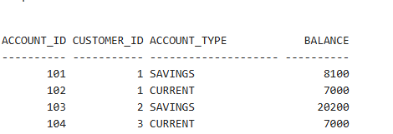

SCENARIO 2:
Scenario 2: The bank wants to implement a bonus scheme for employees based on their performance.
  - Question: Write a stored procedure UpdateEmployeeBonus that updates the salary of employees in a given department by adding a bonus percentage passed as a parameter.

QUERY:

CREATE OR REPLACE PROCEDURE UpdateEmployeeBonus(
p_dept_id IN NUMBER,
p_bonus_percent IN NUMBER
) AS
BEGIN
UPDATE employees
SET salary = salary + (salary * p_bonus_percent / 100)
WHERE department_id = p_dept_id;
COMMIT;
END;
/

OUTPUT:
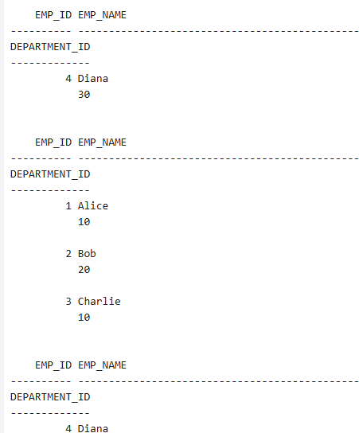

SCENARIO 3:
Scenario 3: Customers should be able to transfer funds between their accounts.
  - Question: Write a stored procedure TransferFunds that transfers a specified amount from one account to another, checking that the source account has sufficient balance before making the transfer.
QUERY:

CREATE OR REPLACE PROCEDURE TransferFunds(
p_from_account IN NUMBER,
p_to_account IN NUMBER,
p_amount IN NUMBER
) AS
v_balance NUMBER;
BEGIN
SELECT balance INTO v_balance FROM accounts WHERE account_id = p_from_account FOR UPDATE;

IF v_balance >= p_amount THEN
UPDATE accounts
SET balance = balance - p_amount
WHERE account_id = p_from_account;

UPDATE accounts
SET balance = balance + p_amount
WHERE account_id = p_to_account;

COMMIT;
ELSE
RAISE_APPLICATION_ERROR(-20001, 'Insufficient balance');
END IF;
END;
/
BEGIN
ProcessMonthlyInterest;
END;
/

BEGIN
UpdateEmployeeBonus(10, 10);
END;
/

BEGIN
TransferFunds(101, 102, 2000);
END;
/
SELECT * FROM accounts;
SELECT * FROM employees;

OUTPUT:

